1. How to compare two JSON have the same properties without order?

var obj1 = { name: "Person 1", age:5 };

var obj2 = { age:5, name: "Person 1" };

var obj1 = { name: "Person 1", age:5 };

;

var obj2 = { age:5, name: "Person 1"};

var flag=true;

if(Object.keys(obj1).length==Object.keys(obj2).length)

{

    for(key in obj1) {

        if(obj1[key] == obj2[key]) {

            continue;

        }

        else {

            flag=false;

            break;

        }

    }

}

else {

    flag=false;

}

console.log("is object equal"+flag);

console:

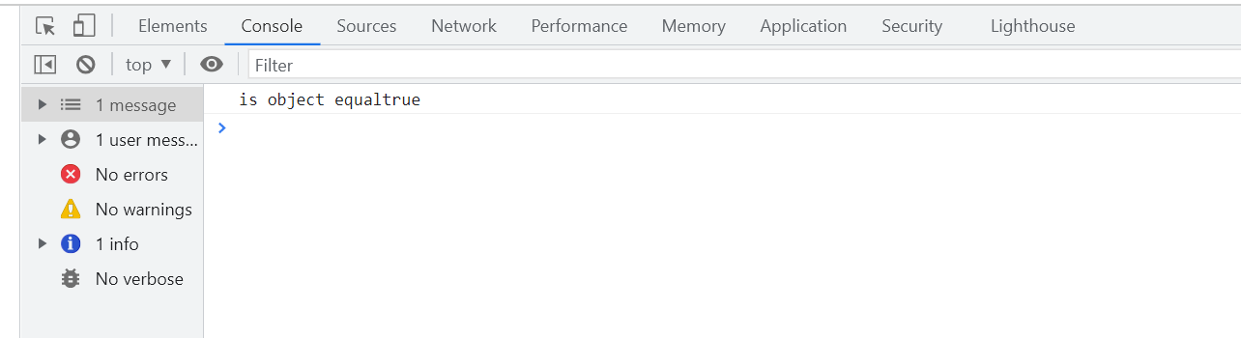

2. Use the rest countries API url -><https://restcountries.eu/rest/v2/all> and display all the country flags in console

Code:

var xhr = new XMLHttpRequest();

xhr.onload = function ()

{

if ((xhr.status >= 200) && (xhr.status <= 400))

{

var t = JSON.parse(this.response);

for (i = 0; i < t.length; i++)

console.log(t[i].flags);

} else {

console.log(xhr.responseText);

}

};

xhr.open("GET","https://restcountries.com/v2/all");

xhr.send();

Screenshot:

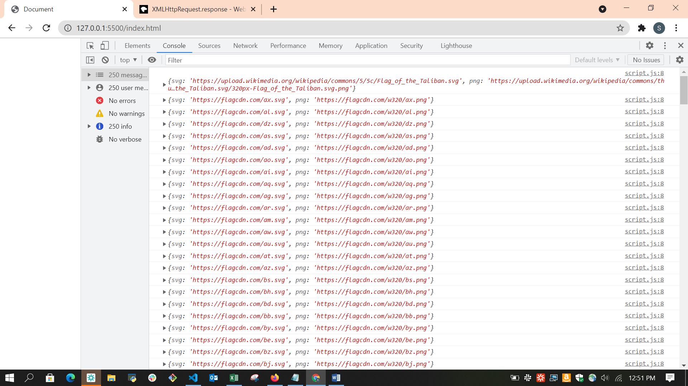

1. 3. Use the same rest countries and print all countries name, region, sub region and population

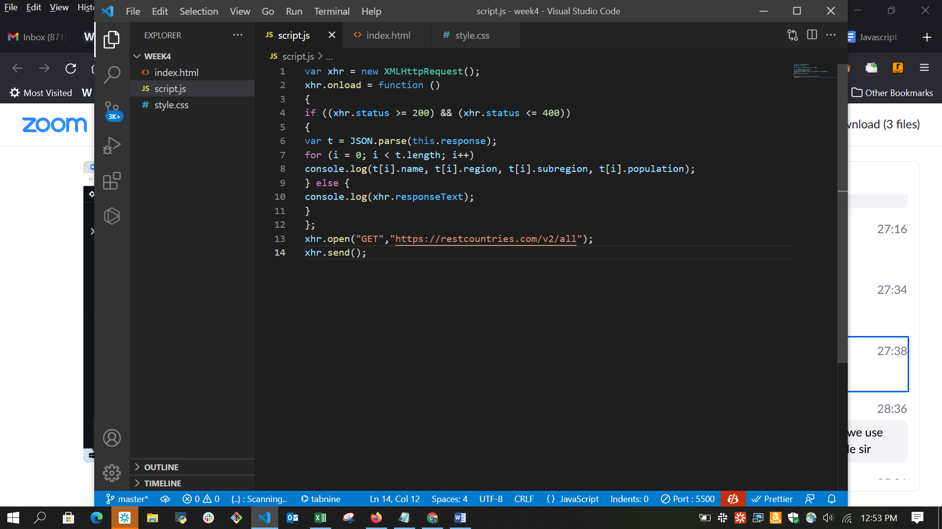

Console

